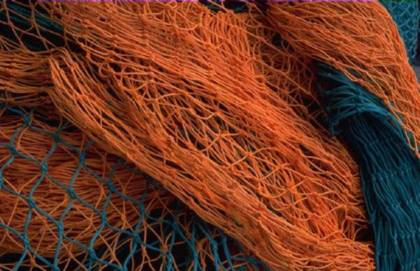
Cast a wider
Novanet

Our new catalogue offers direct links to
more online resources

Dalhousie University Libraries
www.library.dal.ca

Cast a wider
Novanet

Save your search results & strategies
and email them to a friend

Dalhousie University Libraries
www.library.dal.ca

